Eraring should remain open beyond 2025: Minns government energy review

ByMichael McGowan | August 22, 2023 | SMH
The Minns government’s review of the NSW electricity network has recommended the life of Australia’s largest coal-fired power station be extended by making a deal with operator Origin Energy.
After months of speculation over the future of Eraring, the Herald can reveal an Electricity Supply and Reliability Check Up review commissioned by the new Labor government to assess the state’s transition to renewable energy has recommended the power station’s operations should be extended beyond its existing 2025 closure date.
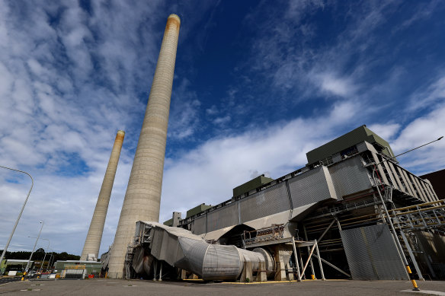
A review of the NSW electricity network commissioned by the Minns government has recommended Origin Energy’s Eraring coal-fired power station remain open beyond 2025.CREDIT:BRENDON THORNE
The review recommends the government enter into negotiations with Origin on an extension of the coal plant at Lake Macquarie, north of Sydney. The confidential cabinet document says that a deal with Origin should be temporary and coupled with an exit policy.
Industry experts estimate prolonging Eraring’s operations could cost between $200 million and $400 million a year. The move is likely to be welcomed by industry, but any extension would pose a political risk for Labor because it would require the use of taxpayer funds to support a high-polluting coal plant.
While the Herald has not seen the report in full, the recommendations say the ongoing use of fossil fuels may be necessary to address energy shortfalls by suggesting there be greater recognition of the role of gas power in firming infrastructure.
The government is yet to sign off on a final version of the report or adopt its recommendations. However, a senior Labor source unauthorised to speak publicly said the call to extend Eraring’s operations in some capacity beyond 2025 would not change.
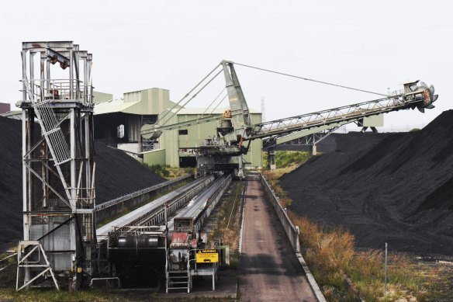
The confidential Cabinet document says that a deal with Origin should be temporary, and coupled with an exit policy.CREDIT:NICK MOIR
The Minns government paid consultancy group Marsden Jacob Associates $217,000 to conduct the energy check-up, which was headed by Cameron O’Reilly, a Keating-era Labor staffer and a former senior energy bureaucrat in NSW.
O’Reilly was also the chief executive of the now-defunct Energy Retailers Association between 2006 and 2015. The group — which became the Australian Energy Council in 2016 — was the peak industry body for retailers in Australia. Its members included Origin.
The appointment has been criticised by the Coalition because of O’Reilly’s past links to the Labor and industry, something Energy Minister Penny Sharpe dismissed.
“Cameron O’Reilly brings enormous insight and experience of the development of energy policy from within and outside government. That is precisely why he was chosen to do this work,” she said.
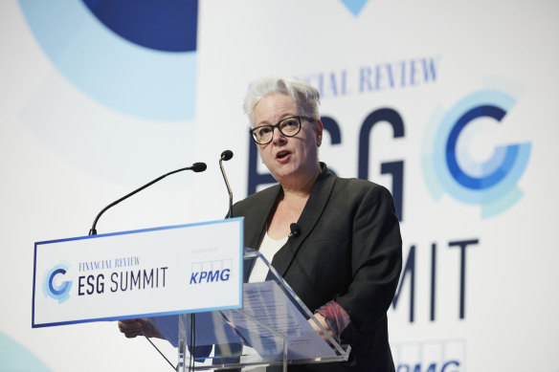
Penny Sharpe has said the government’s response to the energy review would be released by the end of the month.CREDIT:NATALIE BOOG
The report’s contents have been a closely guarded secret within the Minns government, and a spokeswoman for Sharpe declined to comment on the recommendations.
On Sunday, Sharpe said she would not “rule in or out” what was in the check-up, saying it and the government’s response would be released by the end of the month.

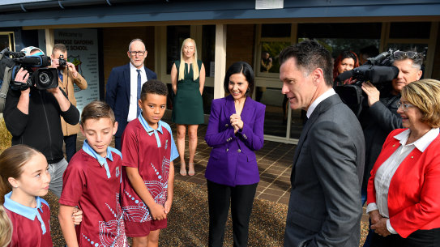

Minns warns path to net zero ‘very narrow’ as govt revisits Eraring closure date
The review’s findings are likely to be welcomed by industry figures concerned about forecast energy shortages from 2027, caused in part by delays to the construction of the Snowy Hydro 2.0 and the Kurri Kurri gas-fired power plant.
However, energy groups such as Climate Energy Finance, a think tank that advocates for a speedier transition to renewables, are critical of the proposal.
A report by CEF in July estimated that keeping Eraring open at only half of its capacity would require the NSW government to pay Origin between $200 million and $400 million a year in subsidies.
While the government is yet to announce its intentions over the future of the 2880-megawatt power station — which Origin announced last year it would close in August 2025 — Premier Chris Minns previously indicated he was open to extending its life.
NSW Treasurer Daniel Mookhey immediately held talks with Origin’s proposed new owner, Canadian investment giant Brookfield, after it won the March election. Last month, Minns indicated that an extension of Eraring might be necessary because “the pace of renewable energy coming online in NSW has been so slow”.
“[It] means we have to revisit some of the existing infrastructure, particularly when it comes to baseload power in the state because [the former government] were so slow at getting planning approvals and renewable energy zones up and running,” he said.
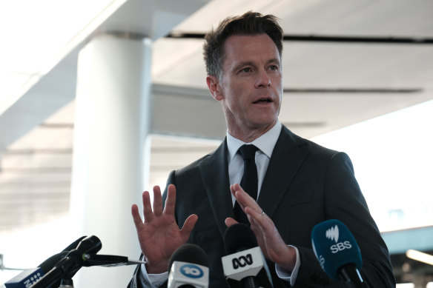
Premier Chris Minns has indicated he was open to extending the life of Eraring.CREDIT:MATT LONGLAND
The recommendations include potential improvements to the state’s renewable energy road map, as well as a greater focus on the role of gas power in firming infrastructure.
Firming or dispatchable power is energy that can be called on at short notice to generate electricity when gaps emerge in supply.
Federal Energy Minister Chris Bowen excluded gas power from a joint Commonwealth-NSW underwriting tender scheme for electricity-firming infrastructure, but NSW has been more pragmatic, with Minns indicating support for the controversial $3.5 billion Narrabri gas project.
https://www.smh.com.au/politics/nsw/eraring-should-remain-open-beyond-2025-minns-government-energy-review-20230821-p5dy79.html

